CMR Aplan for work planning and personnel management
- designed for small service enterprises,
- fast and easy with an intuitive interface,
- multilingual, with working currency settings,
- works on a remote server or on a corporate enterprise server,
- client part in two versions: browser and installable desktop version,
- includes a workflow designer.

Small examples presented in the demo version are profiled for a legal company, which will not interfere with projecting CMR on the profile of your company.
The demo version is located at: https://aplan.opusversion.com/

Terminology and notations
Administrator – controls any parameters of all processes. According to the needs and wishes of the customer – the end user, access levels to viewing and editing parameters can be redistributed between other participants in the process, see the paragraph Access Levels.
Sections or features that are not available in the demo version are marked with *.
Program sections and all menu elements are highlighted within the text in bold, states or status of objects are in italics.
General interface control icons
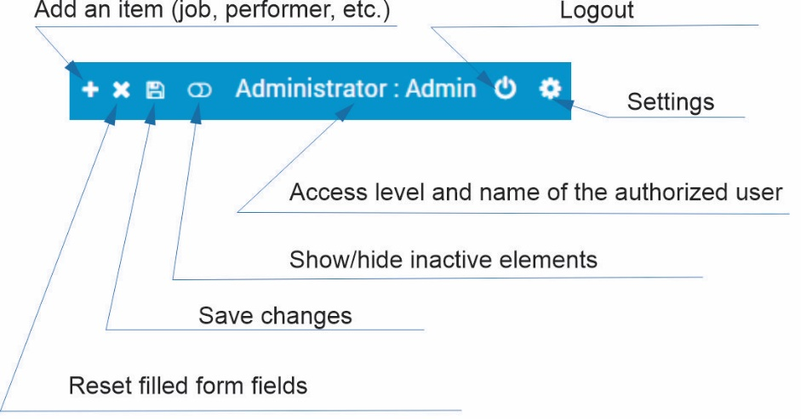
Description
Designer and work planning, Catalogs
Each job can be constructed from standard tasks and/or composite jobs in the section New Job (Fig. 1).
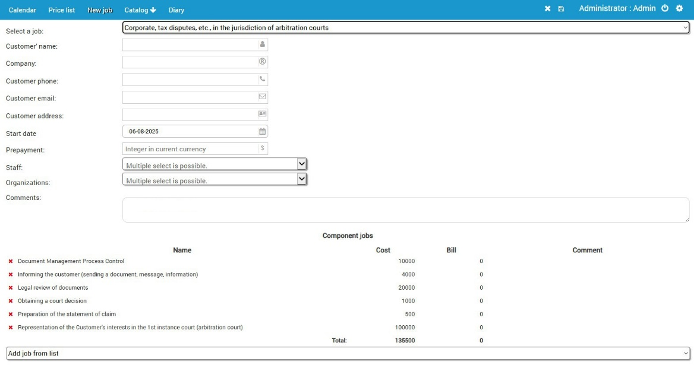 | Fig.1

In this case, the work may have a specified set of tasks or be constructed from a set of standard tasks. A combined option is possible - the work has a specified set of composite works, some of which can be deleted by the designer, and vice versa - the work can be expanded by any combination of tasks from a set of composite works. In addition, the work can be expanded by planned tasks indicating the date and time of their execution (indicating the performer*).
Each job has financial parameters of composite and planned tasks – cost and expenses (for example, state duty, license fee, travel costs, etc.), which are entered or edited in the sections Catalog
-> Component Jobs and Catalogs -> Planned Jobs (Fig. 2).

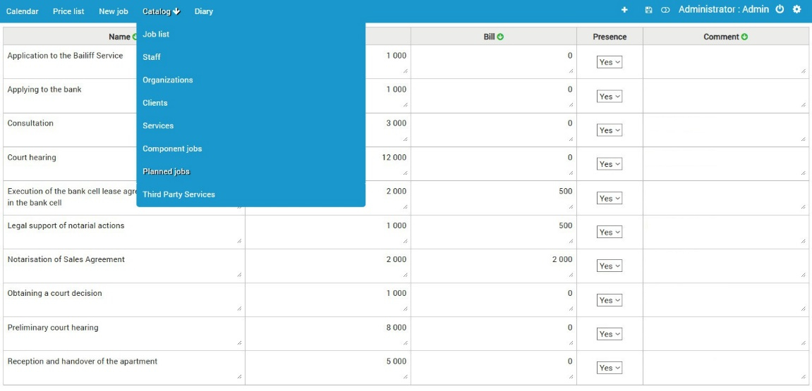 | Fig.2

The cost of work, expenses and money received from the customer are taken into account in the general balance, and the operational receipts and expenses from staff and the customer are taken into account in the operational balance of the Catalogs -> Job List section (Fig. 3).

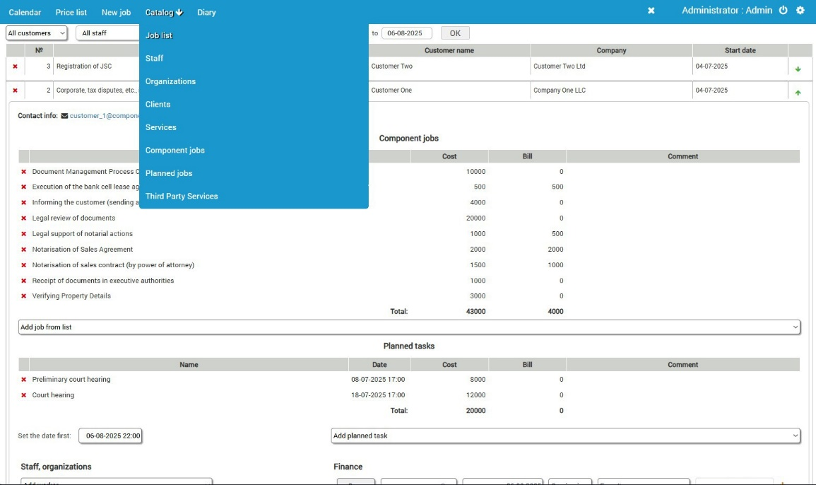 | Fig.3

Each job is assigned performers from the staff and organizations from the set of organizations with which interaction is required (for example, the registration chamber, notary office, courts). In the subsection Catalogs -> Job List it is possible to edit the parameters of the current job.
Personnel, organizations, composition of works, composite and planned tasks and their parameters are entered or edited by the Administrator globally in the corresponding subsection of the "Catalogs" section or partially on-line in the Catalogs -> Job List section. All these sections have a "Present" column. It can be used to hide an inactive element of the section, for example, if the performer has quit. It is impossible to delete inactive elements, since the quit performer has already been registered by the system in previous works, however, it is also impossible to add him to a new work. In addition, some columns with the icon can be sorted alphabetically or by descending/ascending numerical parameters.
Access level
The standard version provides 3 access levels: Administrator, Supervisor and Manager. The levels determine access to the following functions:
- access to program settings (language, currency, sending notifications);
- access to starting a new job;
- access to editing: the composition of components and planned tasks, in general and for current jobs;
- access to viewing and accounting of finances;
- access to editing employee diaries.

Access levels can be increased or decreased according to the requirements of the program customer.

Diary and Kanban *
Kanban, i.e., a graphical representation of the process of performing work, its components and planned work, is built on the basis of the initial work data and the employee Diaries. Any work from the point of view of the execution process has 3 statuses - "to be performed", "in progress" and "completed". The status "to be performed" has no parameters, except for planned tasks, which are assigned a completion date. The status "in progress" is assigned a parameter for binding a specific Performer(s) and a start date for execution. The status "completed" acquires another parameter indicating that the work is completed.
Process monitoring and personnel management, Calendar
The main tool for monitoring and managing personnel is the daily planner (Fig. 4). The administrator assigns composite and/or planned tasks to performers: Job (drop down list of current jobs) -> Task (drop-down list of composite or planned jobs) -> Launch (a component or planned task changes its status from "to be performed" to "in progress". The Status section immediately displays the new status of the selected task, and from there, in turn, the task can be completed, i.e., receive the final status "completed". The administrator also has the option of deleting the task for objective reasons - for example, there is no longer a need to complete it or when it is reassigned to another performer.

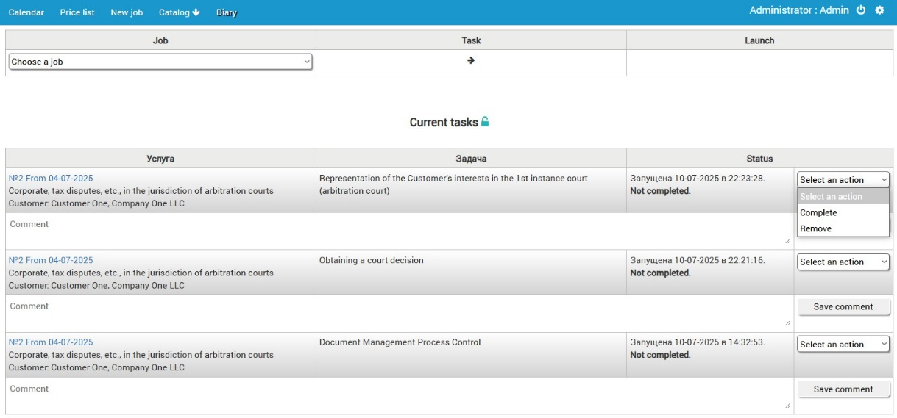 | Fig.4

The status of the work and its financial indicators are monitored in the section Catalogs -> Job List. Here, display filters are available: by customer, by contractor, by completion, by payment or by date range. The second monitoring tool is the section Calendar (Fig. 5), which can be switched between the current year and the current month. The calendar also has filters by customer, by contractor and by year of work performed.
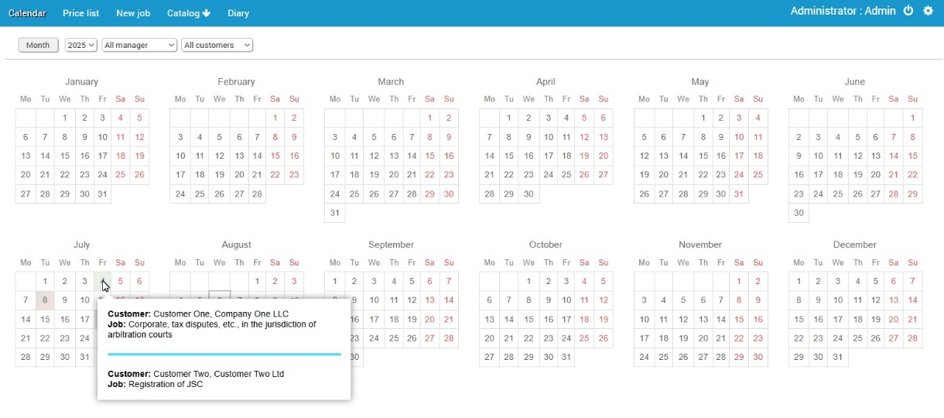 | Fig.5

The calendar dates are colored according to the color scheme by the ranking of the presence of work in progress, planned and completed work. When you hover (or touch) a colored date, a list of works with a short list of their parameters appears, which allows you to go to the selected job in the Catalogs -> Job List section.
Sending notifications
Typically, the mailing is done by e-mail. It is also possible to send via WhatsApp, Telegram or Viber. Notifications are sent to performers: - when attached to a new job - when the time for completing a planned task arrives (2 and/or 1 day in advance).
Uploading documents
Each work can be attached with documents in the following formats: Adobe® pdf, MS Word doc/docx, MS Excel xls/xlsx, jpg, png images using the Documents upload interface, which can also be used to open the corresponding folder (Fig. 6).
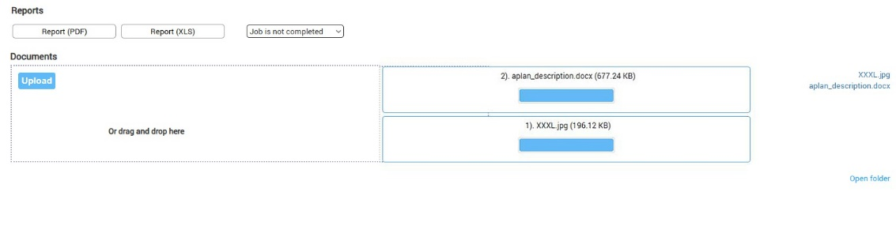 | Fig.6

Reports
CRM can generate 2 types of reports:
- a report for the Administrator or the customer of the work in the section Catalogs -> Job List, in the expanded view of the work parameters - the buttons Report (PDF) and Report (XLS) in the corresponding formats.
- a report for the Administrator or the Contractor in the section Catalogs -> Staff with a choice of date range, allowing you to track the effectiveness of a specific contractor according to the list of works performed by him.
The efficiency of each participant in the work from the staff, such as KPI*, can also be calculated based on the parameters of the number of completed works, the time frame for their completion, financial indicators, - according to the needs and wishes of the CRM customer.
CRM versions and our prices
- Browser version, our server.
The CRM customer accesses the program through any modern browser (Google Chrome, Opera, Safari, Mozilla FF, MS Edge, etc.), the database is stored in encrypted form on our server.

- Desktop version, any server
The customer receives an installation package for N workstations. The database can be stored:
- encrypted on our server;
- encrypted on the remote server of the CRM customer;
- without encryption on the local server of the CRM customer.
____________________________________________________________________________________

